CYBR 520 Lab 1: Introduction to R and

Exploratory Data Analysis (100 points)

# Instructions:

The is a group lab, each team is to submit one submission on eCampus. After the lab is submitted, each group member is to submit a [group member evaluation](https://forms.gle/TvsvercxLsb7sgev9) for each group member (this is worth 15 % of the total grade). We will be using R and Rstudio for this lab. Please read the following the document and provide your answer **below** each question. Keep the formatting of the document as is.

**Dataset: iris**

**R Packages: ggplot2**

Background: The iris dataset is a classic example dataset used for machine learning in R. Most, if not all flowers have a sepal and a petal. The sepal (Figure 1) 1 functions as a protector for the flower and support the petals when the flower is in bloom:

The Iris dataset contains measurements (in cm) of petal length and width, and sepal length and width for 3 species of the iris flower: *iris versicolor, iris setosa,* and *iris virginica* (Figure 2)2. There are exactly 50 observations for each species type, bringing the total number of observations to 150. Each observation is also

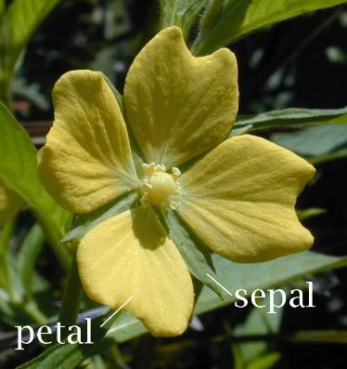

*Figure 1 - Sepal and Petal*

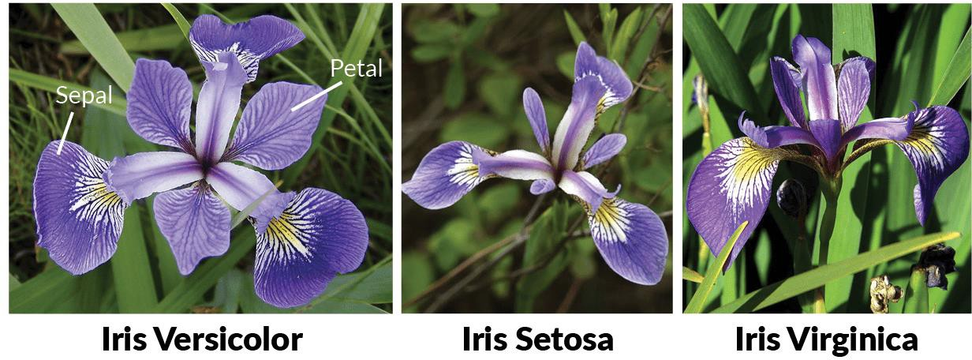

*Figure 2 - Iris Species*

1 https://en.wikipedia.org/wiki/Petal#/media/File:Petal-sepal.jpg

2 <https://www.datacamp.com/community/tutorials/machine-learning-in-r>

assigned membership to a specific species as well. The membership (aka “class label”) is assigned based upon the name of the species “versicolor”, “setosa”, “virginica”.

The iris dataset is already built into R, so you do not have to import the dataset from an external source or file.

## Load in our Data

Launch R Studio

After R Studio has launched, we’re going to need to load in some basic packages. The first package, datasets contains the iris data we’ll be using. We’re also going to use the ggplot2 package for this lab as well.

Type:



We also need to install the ggplot package. You can either go the packages tab and click install. Type in ggplot2 under packages and click install. Or you can type:



Now we need to load the data. Type:



We can look at some rows in the irisi dataset. Type:



Notice that the iris data should now show up in your global environment. Let’s now look at this dataset by typing:



**Question 1: What data is shown by this output? What information can you get about this dataset? (10 points)**

## Exploratory Data Analysis – Iris Sataset

Now let’s do some exploratory data analysis. Exploratory data analysis is a process of performing an initially investigation of the dataset using analysis and visualization techniques to discover patterns, spot outliers and anomalies, and relationships between variables in the data. This is an often skipped, but critical step in any analysis. It can also help you develop a more informed hypothesis for scientific inquiries. In essence, we’re going to try to gain some insight on this dataset.

Let’s load the ggplot package. Type:



Now let’s visualize our data. In R, it’s best that we store our visualization as a variable. To store any function or command, or output as a variable we type an arrow “ <- “ pointing to a variable.

Type:



Now let’s display the plot. Type:



**Question 2: Post a screenshot of the plot below. You can use the export function or a snipping/screen capture tool.**

**Question 3: What observations (if any) can you make from this graph?**

Now notice that in our graph we plotted Sepal.Length as a function of Sepal.Width.

Modify the code above to plot petal length as a function of petal width, and store that graph as a new variable. HINT: use the summary(iris) command first to identify the other two petal variables

**Question 4: Paste your modified code below and a screenshot of your new graph showing petal length and petal width.**

**Question 5:**

1. **What observations (if any) can you make based upon this visualization?**
2. **Which of the previous visualizations shows a clear distinction between all three species?**
3. **Based upon the visualizations, which variables would be most useful for identifying or distinguishing all three species from each other?**

Take a look at some ggplot documentation ([https://datacarpentry.org/R-ecology-lesson/04-](https://datacarpentry.org/R-ecology-lesson/04-visualization-ggplot2.html) [visualization-ggplot2.html](https://datacarpentry.org/R-ecology-lesson/04-visualization-ggplot2.html)).

**Question 6:**

1. **Create a histogram and boxplot visualization of any two variables. See if you can get creative with the coloring and visualization.**
2. **Do you think either of the plots are useful for exploring the data? Paste a copy of your visualizations below and the code you used to create them.**

# Exploratory Data Analysis - Freeform

There are several additional preloaded datasets in R. Explore and choose one of these datasets and conduct an exploratory data analysis.

**Question 7:**

* 1. **Write a brief 1-2 page exploratory data analysis summary of the dataset of your choice, and your exploratory data analysis of that sample dataset.**
  2. **Include a useful visualization or two of the datasets of your choice as well. There are also several cybersecurity related datasets that can be easily loaded into R including the spambase dataset that I’ve loaded on eCampus. Feel free to explore that dataset as your example as well.**

To load a csv file into R, you can use the read.csv command below:



Notice that in R, we use forward slashes for directory navigation, even in Windows.